**W3D1**

Answer1,

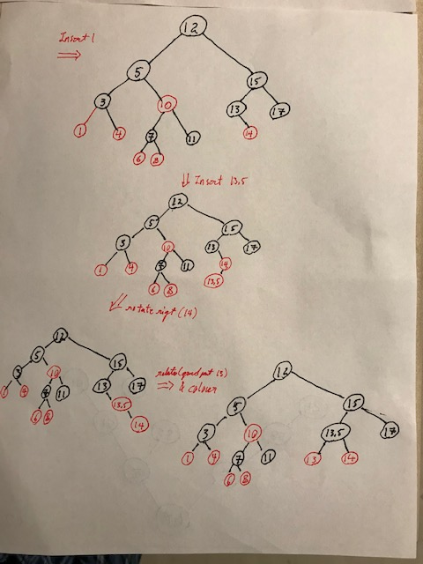

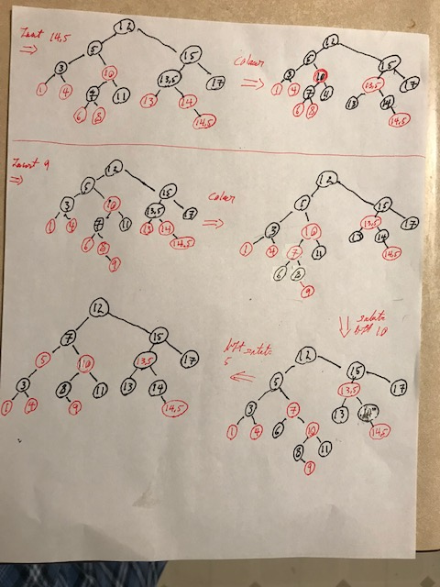

Answer2,

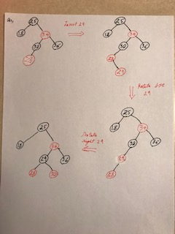

Answer 3

For a N node the number of possible Red black tree is less than 2^N-1

a,

n=1 possible number of red black tree is 1

n=2 possible number of red black tree is 3

n=3 possible number of red black tree is 6

.

.

.

n=N possible number of red black tree less than 2^n-1

b, Maximum value of red to black ratio is 2:1 of a N>3

c, Minimum value of red to black ratio is 0: n for all N.